Noah David Linux Admin

I am currently using Centos 7 and Ubuntu 18.04.4 for my labs

Getting my sed script to work was tricky task I tried many more complex ways of making the script but could not get them to work. So I instead used

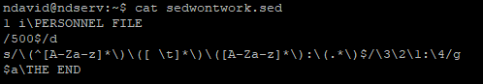

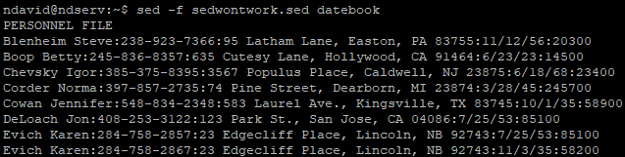That is the script in its very basic form but it performs the required output. Here is an example of a few lines of its output

When installing and configuring Linux machines it best to have the minimal amount of installed services and software for your machine to run securely and optimal.

An important thing when using servers with GUI is using some from FTP from your host to guest OS.

he most important component of Linux is that it is a secure OS. But user error and malicious individuals can change that. Using fail2ban protects your server primarily from SSH attacks. It looks thru logs and adds malicious attempts to the IP tables.

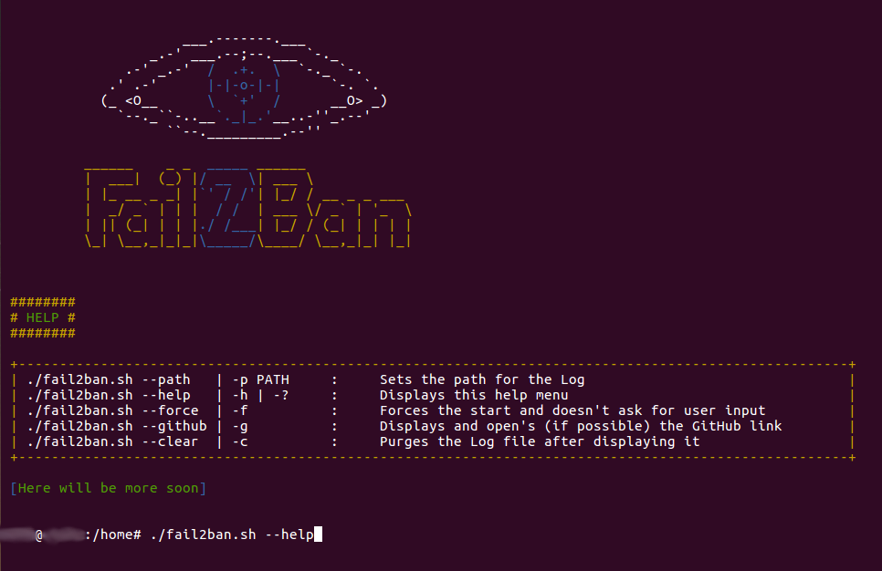

By default servers use port 22 for SSH. One the first security configurations I made was changing the port 1048 so someone doesn’t just use the default